**Enemies, Health and UI**

**Setting up the Scene**

For this tutorial, we’ll be creating a player damage system, corresponding UI and enemies/traps for the player to lose health to. To start, create a sphere and place it in the scene and set to Is Trigger in the inspector. Create and set a new tag called “Enemy”. In this scene, I’ve added a black material and reduced the scale of the sphere to 0.5 as well altered the Z axis so it sits on top of the grid.

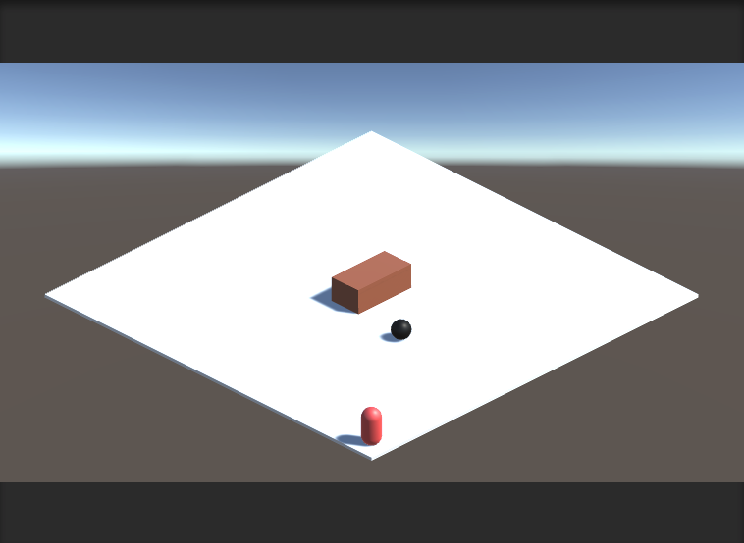

In the hierarchy, create a new canvas. If you’re using multiple enemies/traps, its best for organization purposes to create an empty game object and make it the parent of sphere.

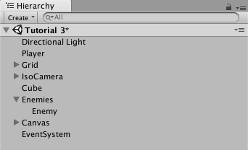

Next, create your UI - I’ve created two PNG images of a larger and smaller white circle in Photoshop to represent a full “heart” and an empty “heart”.

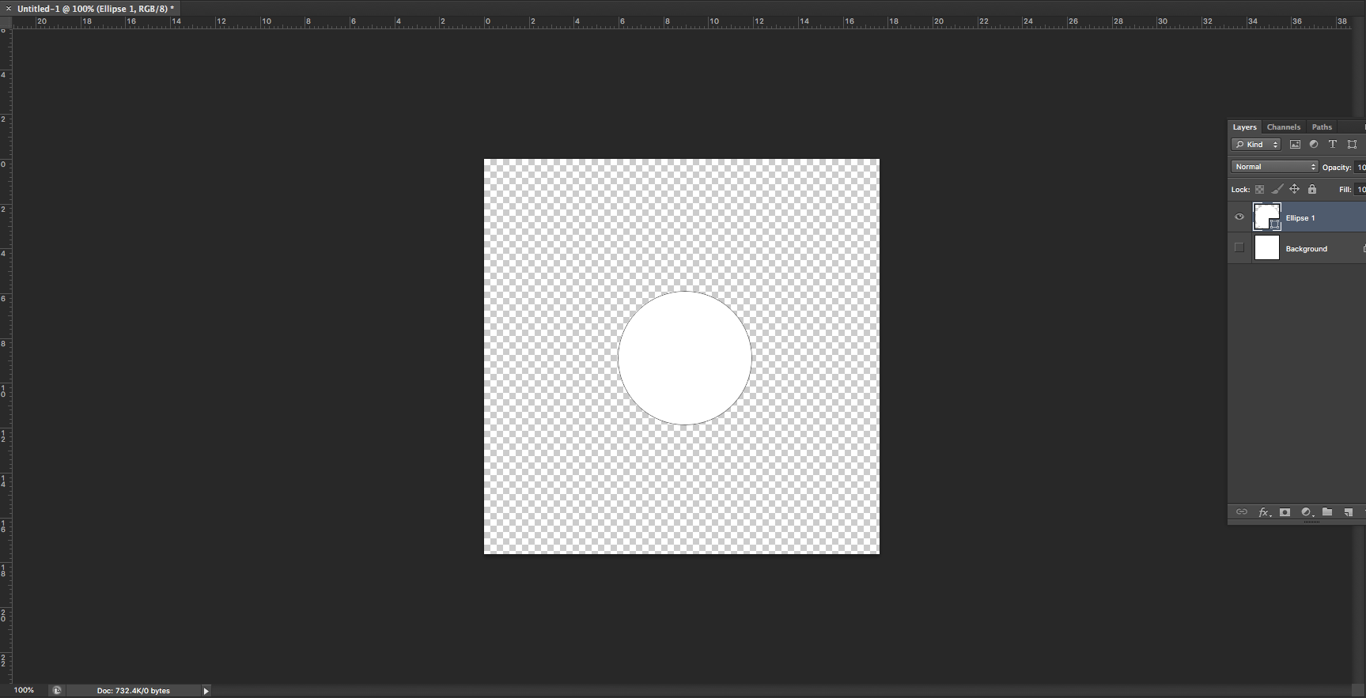

Next, import your PNG files in to unity by dragging and dropping them in to the Assets folder. Click on each of the PNG files and change the texture type to Sprite (2D and UI)

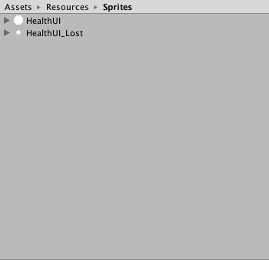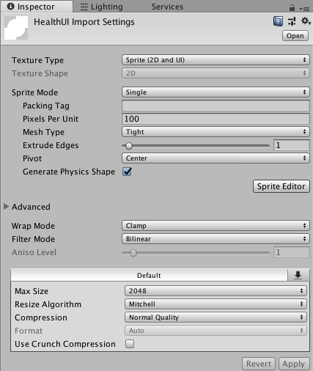

**Setting up UI and player health**

In the PlayerMovement script, Copy and paste the collision If statement and change the tag check to “Enemy” – this will ensure the player cannot walk through the enemy/trap.

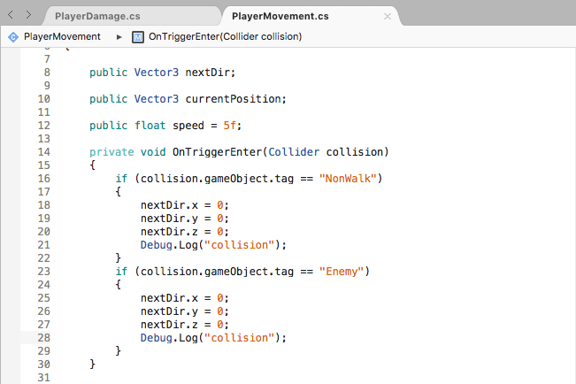

Create a new script called PlayerDamage and add using UnityEngine.UI and using UnityEngine.SceneManagement. This will allow us to set up a scene change if the player loses all their health and to show UI on screen. For the UI, create public integers for HealthUI (as we’ll have 3 lives, this will be set to 3). In addition this, we’ll need an image array (public Image[]) to cycle between two public sprites for our full and empty hearts. To check how much damage the player has taken, we’ll need another integer for playerHealth and one for damage.

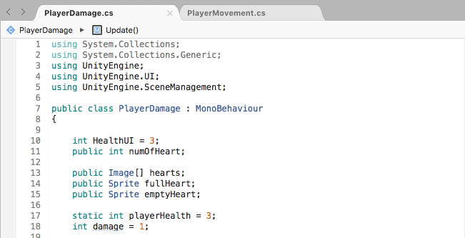

As the number of hearts will be connected to the amount of UI hearts are displayed, we’ll equate the HealthUI to playerHealth in the Start function. Similar to the movement script, create a Void OnTriggerEnter (Collider collision) and create an if statement that checks for the Enemy tag. If the enemy tag is detected, playerHealth and HealthUI will be subtracted by 1. In the Update function, we’ll be using a for loop to check through our array to decide if a full heart of empty heart should be displayed. Finally, create an if statement to check the the player’s health. Optionally, If the players health is equal to 0, then the a game over screen will be loaded if the scene has been added to the build settings.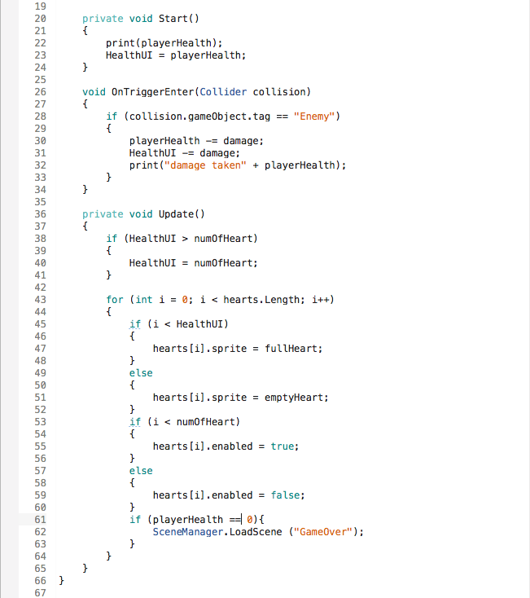

In the hierarchy, right click and create a new image under UI. We’ll assign the full heart PNG to this image and duplicate it 3 times. Position the hearts wherever you wish on the screen using the POS X,Y and Z variables.

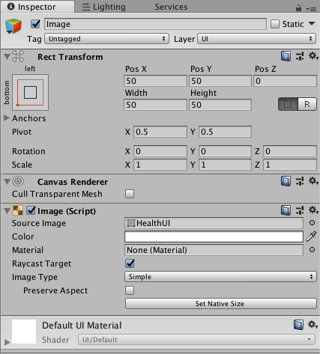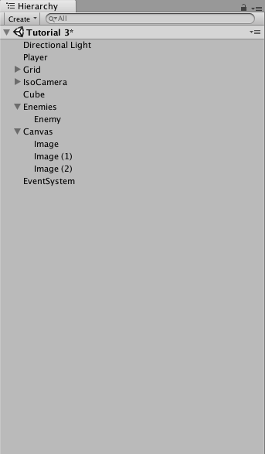

Assign the player damage script to the player game object and lock the inspector by clicking the lock icon. In the player damage script, drag and drop the 3 heart images on to the Hearts drop down menu – this will insert the image in to the array. Finally add the full heart and empty heart PNG images to their respective slots.

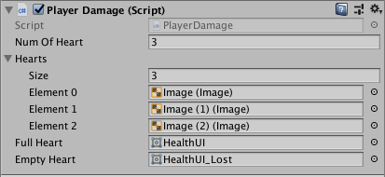

You should now have a functioning health bar which depletes upon taking damage from an enemy/trap

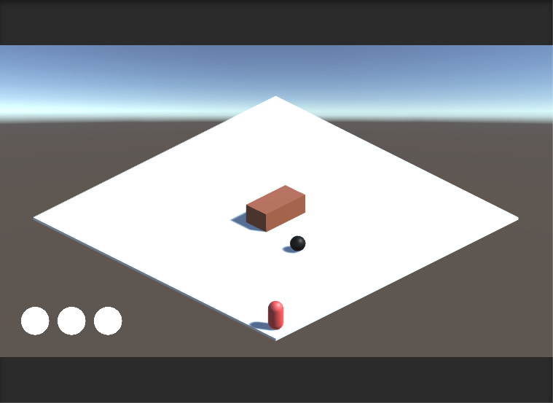

In the next tutorial, we’ll be adding a countdown timer, collectibles and a win/loss clause.